Relevant reports
Date of flight | 6.6.2018
Time of flight | 0800-1800
Departure point, destination and any other locations | Dododa-Chidudu-Kilimatinde-Chidudu-Kilimatinde-Chidudu-Dodoma
Pilot name/s | Jarkko Korhonen
Aircraft registration details | 5H-SIL
Organisation flown | Kilimatinde safari
Organisation contact | Ruth Kambenga
iBase ref numbers

One day at Kilimatinde safari
On the Wednesday 6:th of June 2018 I started Kilimatinde safari with 5H-SIL , because 5H-MSO had 50 hours maintenance in Dodoma . I arrived already day before to Dodoma, to be ready early in the morning for evangelism and mobile clinic work. On Tuesday we celebrated Central Aviation Services (old MAF guys) to receive their own AMO after four years of transition! Everything happens really slowly in Tanzania, but then in one sunny day you can have habari njema- good news!
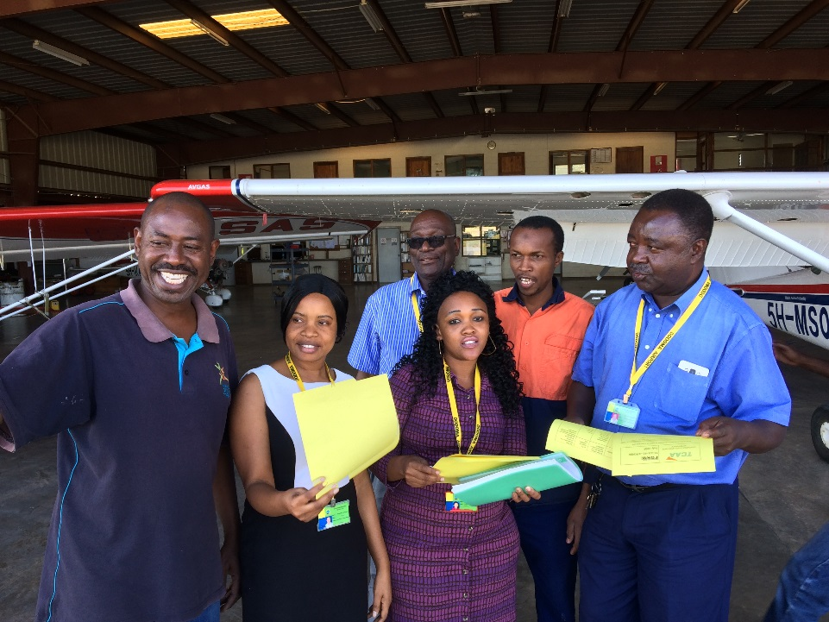
I took evangelist team, four evangelist and pastors from Dodoma to Chidudu with 5H-SIL. 5H-SIL feels different to fly than our two MAF planes. From Chidudu I flew village chairman to Kilimatinde, because he needed hospital care. In Kilimatinde you need to be really alert, because normally people are hanging around or crossing narrow runway. If the grass is long on sides, it is hard to see them. We are planning to build a fence here and have also communicated with the Kilimatinde hospital about the matters. From Kilimatinde I picked five nurses, vaccines and other medical equipment to Chidudu mobile clinic. This time also fourth year medical student Sophie Roe from Birmingham university joined the local medical team. She was doing her practical medical training here at Kilimatinde (Anglican) hospital. She was interested to see how things are done in Africa and wanted to help people generally in the future with her skills.
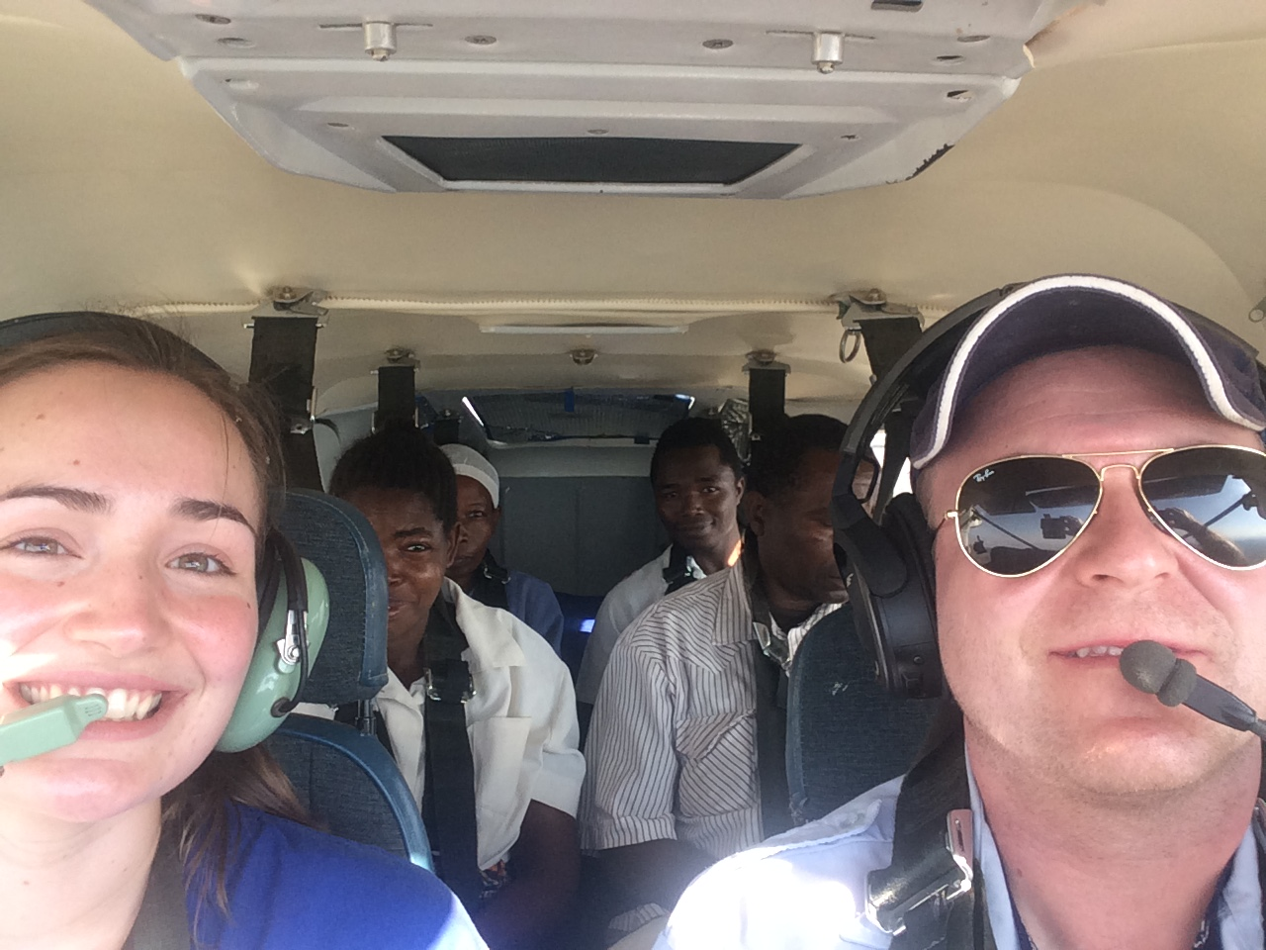
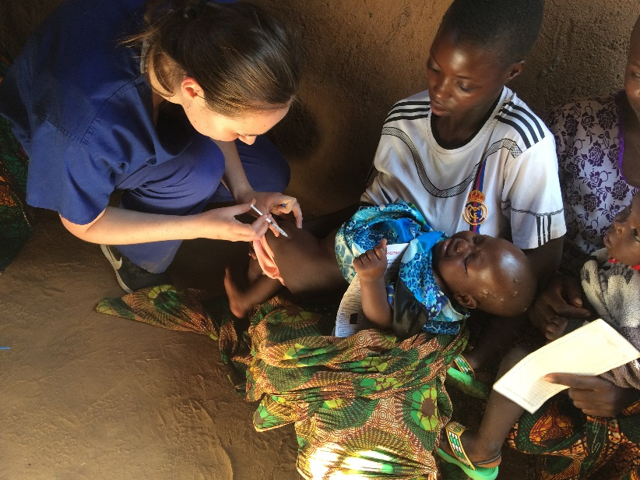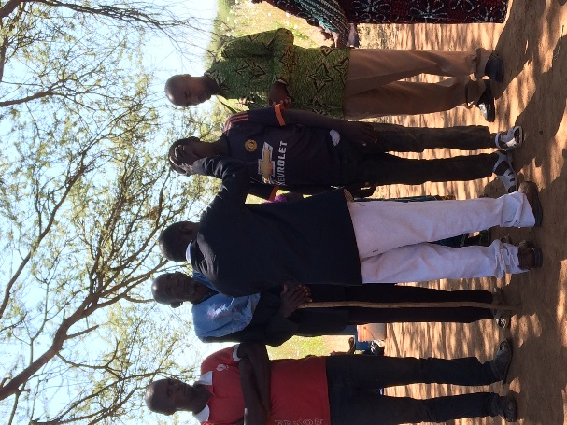
While mamas and babys were on clinic, kids received Sunday school under the shade of the wing. About 150 people received the Word of God and some of them were also prayed for. Both elements are important at our work praying and preaching and medical care. For example catarax eye problems God normally works through hands of doctors. In medical clinic over 100 babies/mamas were treated.
On afternoon we were again in hurry to get medical team back to Kilimatinde hospital. Everything went okay and I returned on time back to Chidudu. After landing, when taxiing the plane, I had suddenly to use more power to taxiing and plane was also turning abnormally. I prayed, that God please no puncture. In Chidudu there is no mobile network, even HF doesn’t work well and there are no roads to the village… I opened the door and saw left main wheel completely flat! Oh no, I said, it seemed we had to overnight at Chidudu… We were already running late without communication, I decided only thing we could try to do is to pump the tyre and see how big is the puncture… I try to find the pump from the pod, but it wasn’t there. It had been moved before to another plane, which had broken pump. Thanks to God villagers had small bicycle pump and they started to pump. We checked the tyre and couldn’t find anything visible? Also the tyre seemed to hold air! We loaded the plane, while they continued to pump. Then we did very quick departure and could get airborne normally. It was a relief to be on the way to Dodoma, which has maintenance facilities. I was preparing for flat main tyre landing, but the tyre looked still normal in the air. Even after landing it hold the air and was normal. I got the evangelist team back, I was back on time limits and indeed very thankful to God that we didn’t need to overnight at Chidudu after the long day. It remained a mystery what happened to tyre at Chidudu?
