Relevant reports
Date of flight | 1.6.2018
Time of flight | 1000-1700
Departure point, destination and any other locations | South Masai safari Katahe and Lesirwai
Pilot name/s | Jarkko Korhonen
Aircraft registration details | 5H-MSO
Organisation flown | Malambo safari
Organisation contact | Martha and Yohana evangelists
iBase ref numbers

After the wet rainy season, we have moved to the cold season in Tanzania. Friday morning 1.6.2018 I had to wait for the cloud base to raise enough to be able to fly to the South Masai area. Even then clouds hang sometimes on low level until late afternoon. Last month we missed clinics in this area, so it was important to get there this Friday. With new flight instruments and flight pads, you can get much more situational awareness, if you need to fly low level. You know what is ahead and you can see more information on one screen. Also new instruments are more reliable and as a backup you have separate flight pad system. You still need to keep your eyes open and be able to see ahead, because in Tanzania we fly only in visual meteorological conditions. Anyway, other equipments should support you when you make decisions on cockpit. It is important they are reliable.
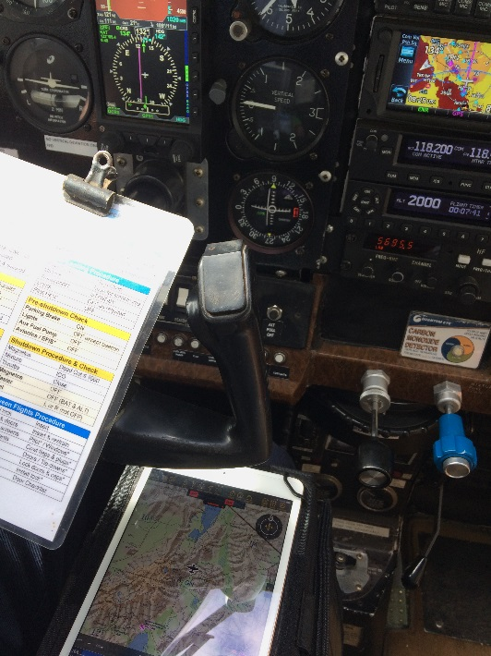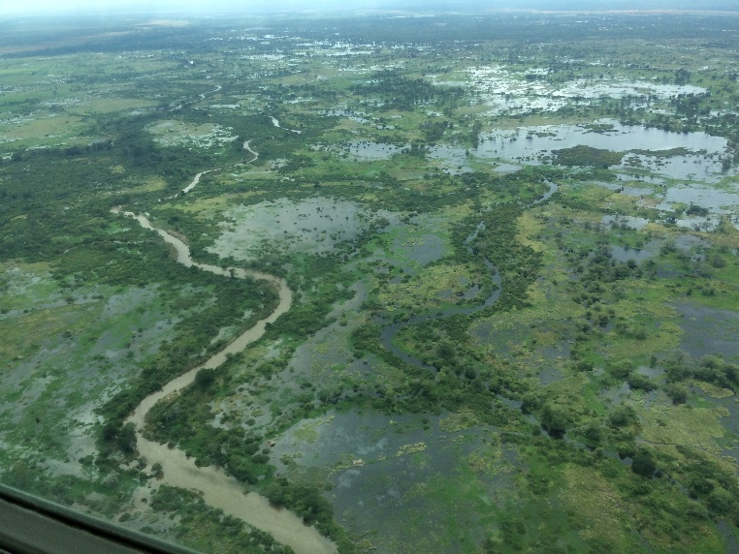
Flight pad in use and new instruments. Flooded Ruvu river.
Only when approaching destination Katahe from Arusha, I started to see some sunlight pushing through the clouds. Otherwise I could see below me in Rufu valley a lot of water. A dam had been opened on upstream and Ruvu river had flooded so much that even another airstrip, which is located several kilometres from the actual river, was in risk to be flooded! We picked up a medical team and one evangelist from Katehe to work in this other village called Lesirwai. When we approached village, we could see the floods had stopped only half a kilometre away from the airstrip. We were warmly welcomed, and a much needed mobile clinic could take a place.
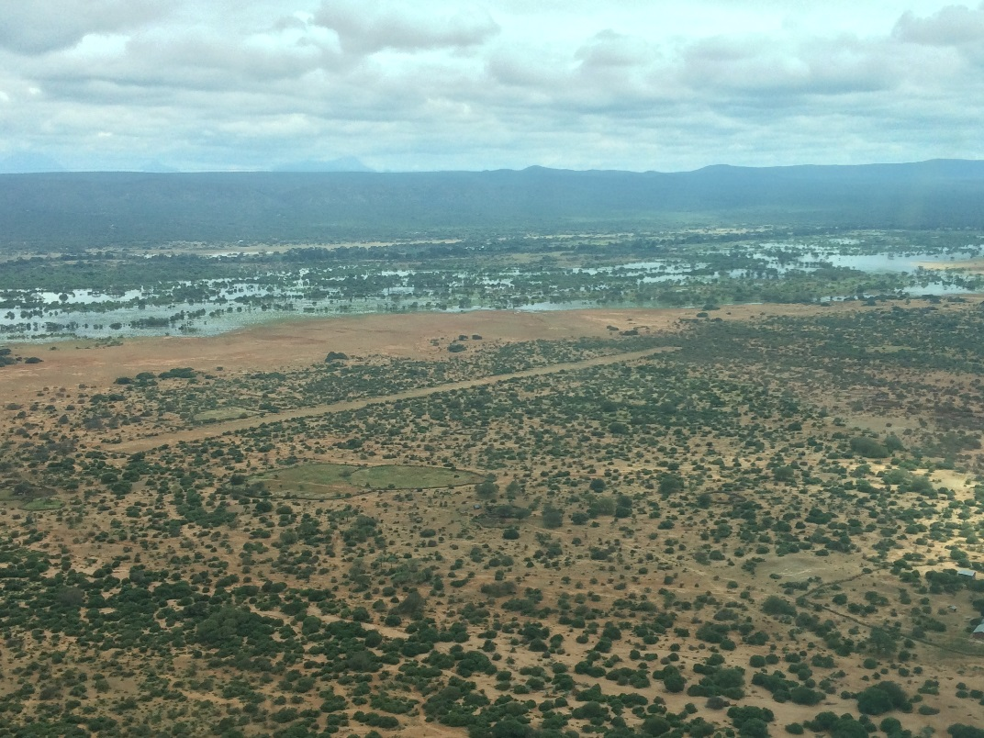 Lesirwai airstrip
Flight pad was also useful on the ground. I was sharing from a MAF Wifi bible unit a legendary Jesus film in kimasai language. This was the first time for many to see living picture and to hear a movie on their own language. We could only watch about half of the film, because time was running out.
Normally you have in the flight pad also all the manuals and pre-flight documents, which you can check on the ground. We are very thankful to Finnish congregation, who donated funds for these flight pads.
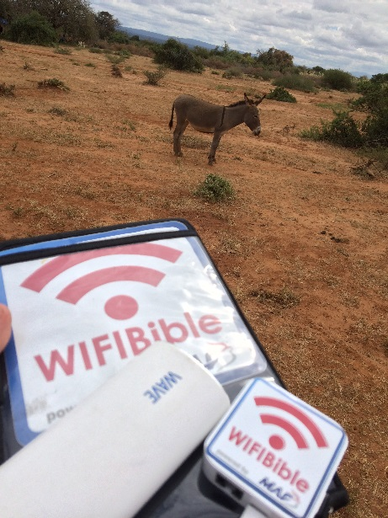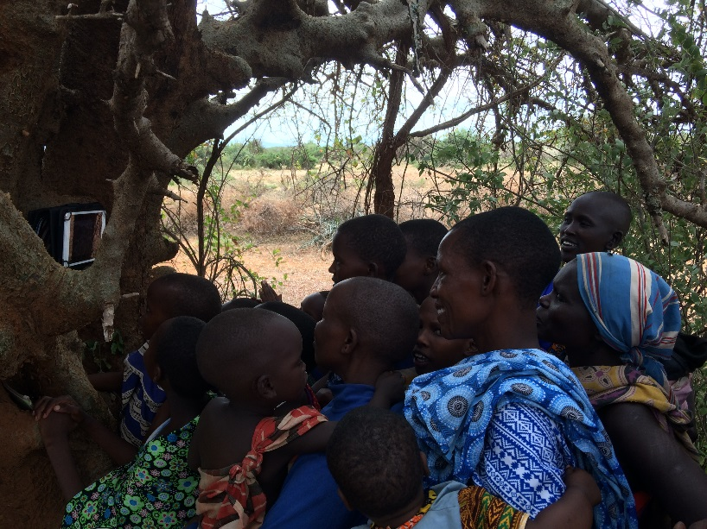
New and old way to bring Gospel! Jesus film on masai language.
Masais were asking help for Malaria. Because of the flooding, they don’t only get fish for food and green grass for their cattle, but also billions of mosquitos. Kids can’t sleep, because of their sound! More dangerously mosquitos bring malaria. Also with flooding there is a higher risk of cholera in this area. Please pray for Masai in South Masai area. We are planning to expand the work once aviation authority grants permissions. At the moment we normally serve about 150-200 people in Lesirwai and Katahe villages. With one or two new airstrips we can double or triple the impact. An important part of the work is also teaching, not only medical related things, but also Word of God. Evangelists are also very happy, if they can use modern technology, like wifibible, for sharing the God’s kingdom. Please pray for this work and thank you for all the support so far.
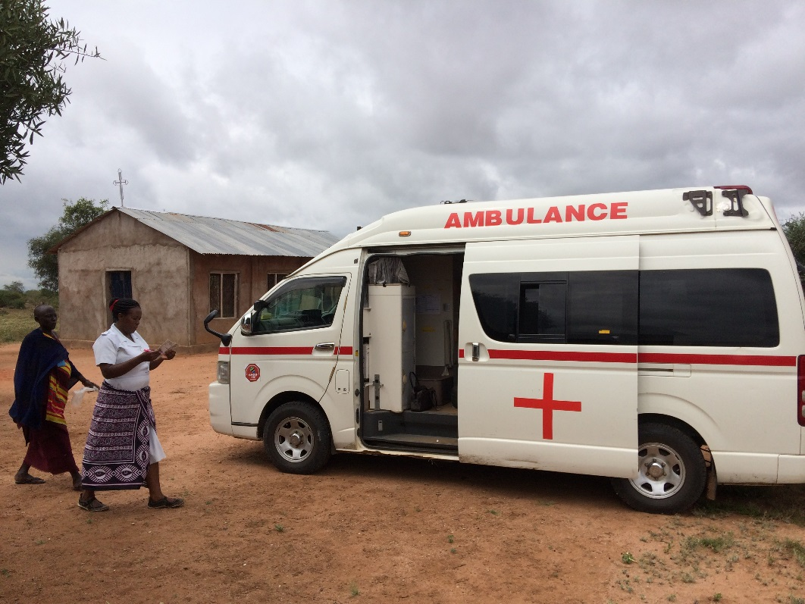
Ambulance bring nurses to Katahe, from where we fly to Lesirwai. Clinic is done also here.
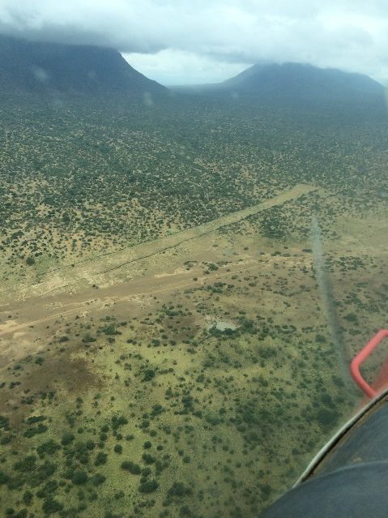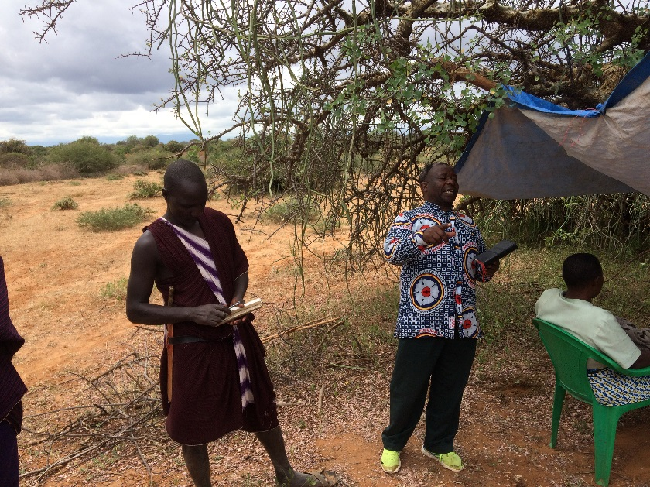Meserani airstrip we plan to use after getting permission. Evangelist Yohana is preaching.

